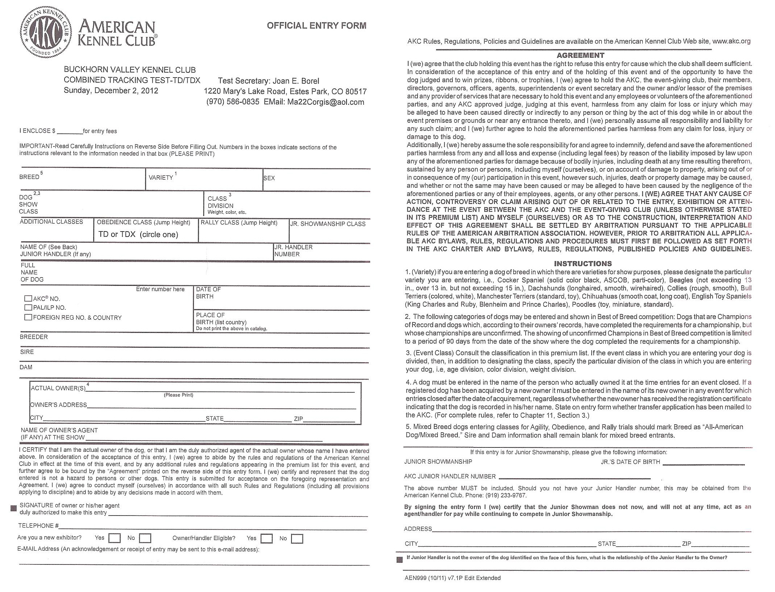

Buckhorn Valley Kennel Club
1st Annual Tracking Dog Urban Test (Event # 2014083509)
Sunday, July 20, 2014
Colorado State University, Fort Collins CO
Mail to: Hildy Morgan, 4824 Regency Dr., Fort Collins, CO 80526

